DNA sequencing Facility, CSIR-IMTECH

(Sanger sequencing)

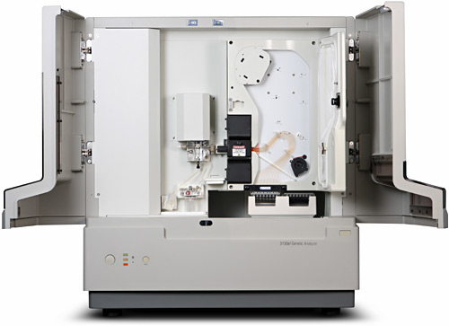

Equipment & Specifications:

Applied Biosystems 3130xl Genetic Analyzer
High throughput, automated DNA sequencing services are currently provided by the use of the state of the art Applied Biosystems 3130xL Genetic Analyzer. This capillary based instrument has the capability to run up to 16 samples in one run with read lengths of greater that 1,000 bases (PHRED Q20 scores >800) within 2 hours.

- Auto-loading of samples performed from two micro-titer plates: 96 well format
- Arrays with sixteen capillaries in two different lengths: 36 and 50 cm
- Automated delivery system for POP-7 polymer
- Argon laser with primary excitations at 488 and 515 nm
- Detection of up to 5 dyes for sequencing and fragment analysis
- CCD detection technology and spectrograph for color separation
- Simultaneous dual-side illumination detection system to maximize signal uniformity and sensitivity
- Software available for DNA sequencing and base calling (Sequencing Analysis v5.2)
Services provided:
DNA sequencing of plasmids and PCR products (using BDT v3.1).

